Overview:

Kiva.org is a leading online crowdfunding platform dedicated to providing financial services to underserved populations worldwide. With over $1 billion in loans distributed to over 2 million borrowers, Kiva empowers individuals to overcome poverty and build sustainable livelihoods. I have thoroughly analyzed the dataset spanning 2014 to 2017, sourced from Kiva and available on Kaggle. Through detailed examination, I've uncovered insights into lending patterns, borrower demographics, and regional dynamics, contributing to Kiva's mission of poverty alleviation and community empowerment.

Findings:

* On further analysis we observed close to 0.2% of total instances where the application was directly applied as to 99% of the application being applied via KIVA partner’s support.

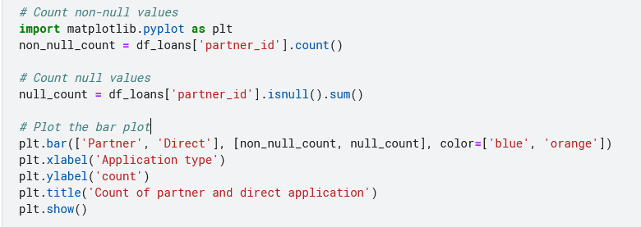

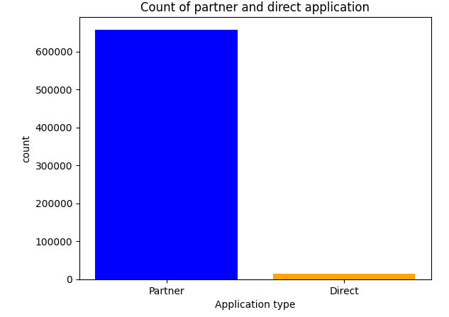

* As we can see from below snip attached our mean hovers around 12 days for LTA( Loan turnaround time), signifying areas of improvement for loan process. We have instances where borrower have waited for 60+ days to get the loan funded.

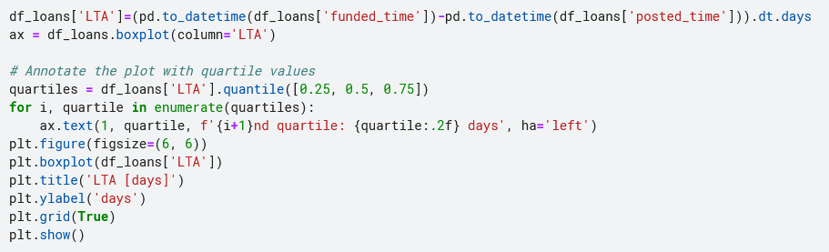

*Code Snippet:LTA*

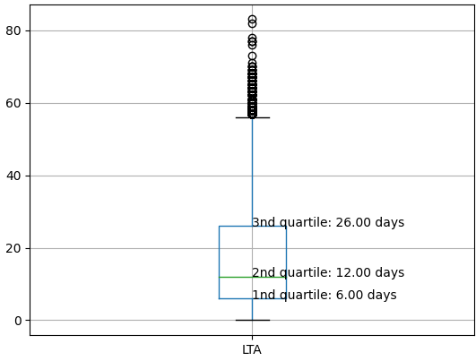

KPIs:

* **DAR**( Direct Application rate): defined as No of direct application / Total application *100
* **WCR**(Website Conversion rate): defined as No. of completed application / Total number of unique website visitors * 100
* **LTA**(Loan Turnaround Time): defined as Time taken to allocate the fund from the time the application is filed via partner or direct application

Pros:

* By boosting direct application over the portal we can incentivize lending/borrowing process with starting interest as low as 0.5%.
* Using this method, the chances of outreach within a community of region will be boosted.
* KIVA can save money on advertising and save on partner nominal fees considering the rural areas operational expenses.
* LTA can be crucial in understanding the challenge that borrowers may face considering the majority of the application is filed via partner support.

Cons:

* This approach although can boost and bring new incentives to KIVA but may drastically cut the partner earning and may reduce the loan process as data is not readily available for such rural areas and underprivileged may not benefit the challenge that KIVA wants to address.
* WCR can be subjective considering the fact as majority of the funds are allocated to partner and can hinder the visibility of direct portal available for lending process.

Recommendation:

* **Incentivize Direct Applications**: Offer attractive starting interest rates, such as 0.5%, for direct applications to incentivize borrowers to apply directly through the portal
* **Optimize Direct Application Rate (DAR) and Website Conversion Rate (WCR)**:Focus on strategies to increase the DAR by making the direct application process more user-friendly and accessible. Improve the website experience to enhance the WCR, ensuring that visitors are encouraged to complete applications.
* **Attain Global Outreach:** Maintain partnerships with local organizations and partners to continue reaching underprivileged communities and rural areas.
* **Monitor and Improve Loan Turnaround Time (LTA)**:Continuously track LTA to understand the efficiency of fund allocation and identify areas for improvement. Streamline internal processes to reduce turnaround time and ensure timely allocation of funds to borrowers.
* **Invest in Data Collection and Analysis**: The dataset contains MPI index for 2014-2017 which is obsolete and requires fresh findings to stay updated with realtime information. Enhance data collection efforts, particularly in rural and underprivileged areas, to better understand borrower needs and challenges.